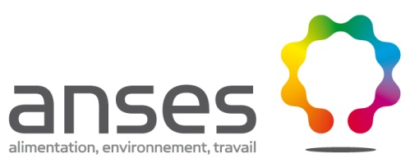

Being addressed | Solution exists but there are economic issues | Issues with applying cascade | Existing solution | No solution in sight  Expert input to be conducted

Bees
Pathology | Therapeutic alternatives  identified | Health impact | Economic impact | Comments
Nosemosis | No available drug.  No MRL for Fumagillin. | 4 | 4 | Risk of unauthorised drugs being used.
American foulbrood | No authorised drug. | 5 | 5 | Risk of AB being used and resistance developing.  No need for drug. Treatment by transferring.
Varroosis |  | 5 | 5 | Authorised drugs ineffective, varroa resistance?  RFSA (French Network for Animal Health) bee group: efficacy protocol for drugs to combat varroosis.

